**Building a Simple Electric Motor**

The electric motor is an important device because it converts electromagnet energy into mechanical energy. They can be found in DVD drives, microwave ovens, blenders, power tools, vehicles, and toys. The electric motor works by creating electromagnets and then using them to push or pull other magnets, causing motion!

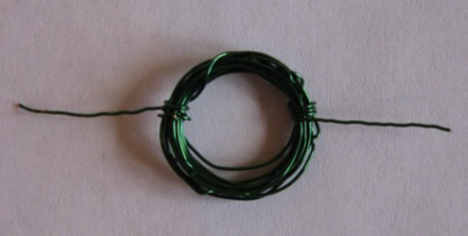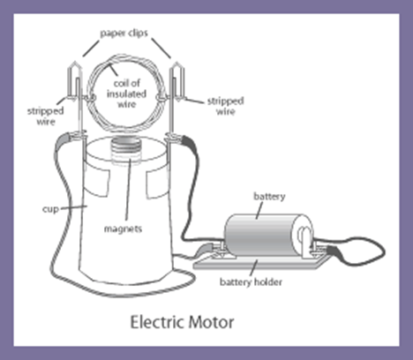

**Procedure:**

* Coat **one** side of *only* **one** of the wire tails with permanent marker (hold the coil perpendicular to the desk while you do this so that the mark is in the correct position on the tail).
* Set aside your coil.
* Take the plastic cup with the magnets attached. **DO NOT REMOVE THE MAGNETS.**
* Wrap the rubber bands around the bottom edge of the cup
* Bend the paperclips so that they can be placed between the cup and the rubber bands and create a cradle for the wire coil to spin in.
* Place the coil in the cradle and spin it to make sure it can spin freely and is placed directly above the magnets. Make any necessary adjustments.
* Connect red alligator clip to the left paperclip and the black alligator clip to the right paper clip. Make sure they are above the rubber bands!
* Give the coil a gentle spin. If the coil does not continue to spin on its own, make any necessary adjustments until it does continue to spin.

**Answer the following questions in your lab notebook.**

1. Based on what you saw in the above experiment, list at least 2 things that you think could affect the speed of your motor, and how they would affect the speed (speed it up or slow it down?).
2. Describe a way you could reverse the direction of the spin of your motor.
3. Using your recently gained knowledge of electric motors, hypothesize how you think an electric generator works.